

December 13, 2012

This is a prototype Green Home just done this year in California (of course). It has 3 bedrooms / 3 baths, is 1,700 sq. ft. and targeted to sell for $ 300,000.00. Backers of the demonstration project say that the Craftsman-style house just finished at the Orange County Great Park can be reproduced for just $85 to $125 per square foot — equivalent to what most tract homes cost to build today. http://www.abcgreenhome.com/

News Video: http://peninsulapublishinginc.com/blog/2012/10/abc-green-home-opens-doors-at-oc-great-park/

Since California is seeking to make Net-Zero energy use mandatory by 2020, this model home and its sustainability template will show how to achieve Net-Zero now. There are few if any, affordable entry-level certified green homes being built by production homebuilders for sale in America, so the home is expected to serve as a template for future housing. The ABC Green Home will be on display at the Great Park for the next year and open to the public.

Our Eco Village Home has similar goals in mind with a different twist. We are also aiming at building costs being $ 55.00 - $ 100.00 per square foot. Our goal for early next year is to build a prototype Eco Village Model Home. We hope to have this completed for a selling cost of $ 150,000.00. This would be a totally sustainable DC current powered home with the capability to connect to the grid - or not depending on the need? This idea uses existing technology to make a totally self-sufficient home based on solar and battery technology. We combine this with existing insulated building panel technology, and you have a home that is warm in the winter and cool in the summer. We incorporate a 12V DC electrical system that enables the use of low voltage LED lighting, modern appliances such as refrigerators, induction cook tops and convection steam ovens.

You will never have to rely on fossil fuels again, and will be able to sell your excess solar generated electricity back to the grid, helping to pay for your home investment from the beginning. How much is your energy deficient house worth now - and would you trade for one that offers ecological sustainability? It is a question a lot of people will be asking themselves soon. The housing industry is due for a rebound and now is the time to re-think the envelope.

This is Plan -1 for the Eco Home:

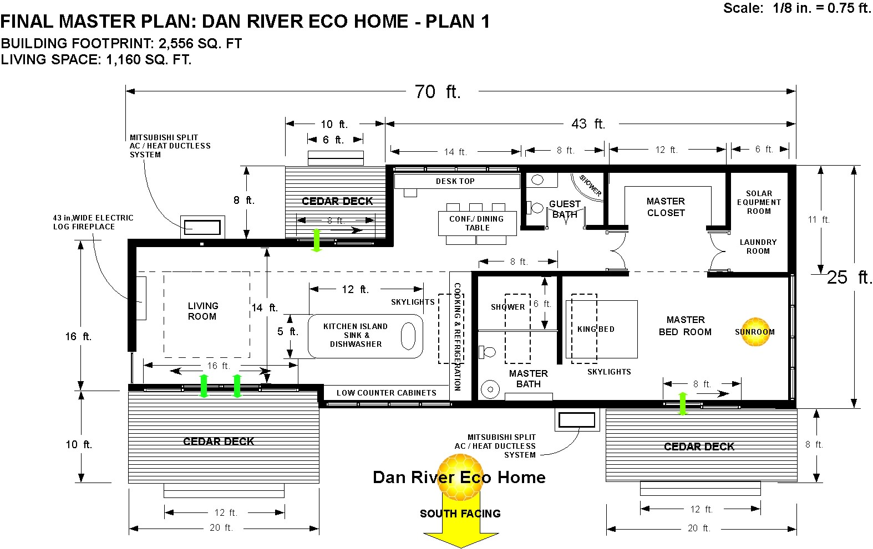

This is Plan -2 for the Eco Home:

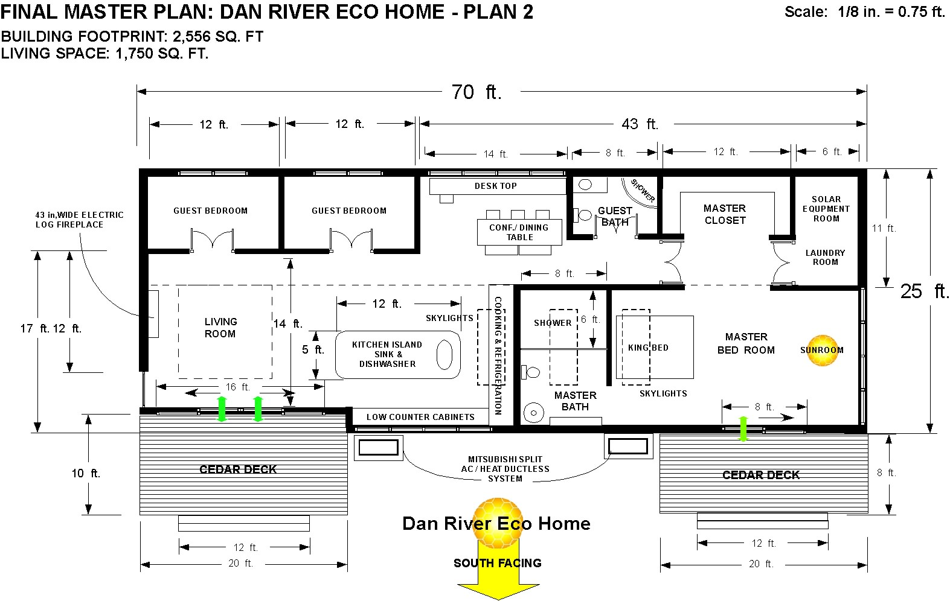

Eventually your Eco Home will be a source of income for you. You will be immune to blackouts and natural disasters, like Hurricane Sandy, or other natural weather related events. Regardless of how you stand on “climate change,” we have researched the needs of senior citizens and found that the ideal square footage of living space is approximately 1,000 sq, ft of livable space. Many seniors live alone now in houses way too big for their needs, but even those who have a partner, do not feel like they need any more space. The Eco Home is an open plan design that features a large kitchen with an island feature that is open to the living room. The basic plan offers a home office and a luxurious master bedroom (with a bonus sunroom) and a luxury master bathroom. A large master closet space tops it all off as well as exterior cedar decks front and back that expand the livable space. The laundry & solar battery room is off the master closet space. Heating and Air Conditioning are by two separate units -9,000 Btu 19 SEER Ductless Mini Split - DC Air Conditioner & Heat Pumps.

The Roof is the key Energy Feature of Your Eco Home:

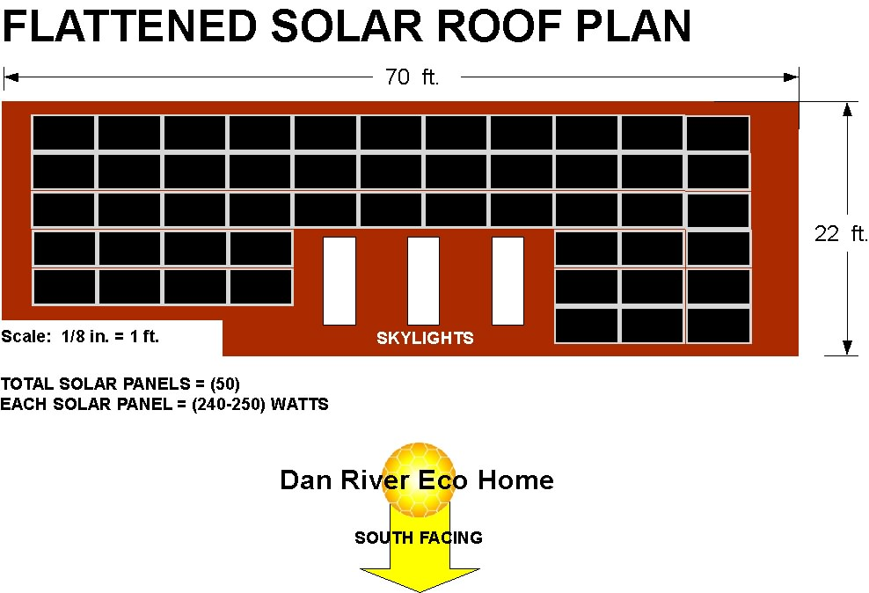

We will use the latest model Solar Panels with the highest efficiency ratings for our Solar System. As this is rapidly changing we will source the best product at the time we build your Eco Home.

The concept is to cluster these homes into Eco Villages which can form small enclaves of people that share their experiences and create a social fabric based on renewable energy and common needs. We plan on using a group of (6) at a time to fit the basic property lots available in the market.

This is the Prototype Eco Village Master Plan Cluster:

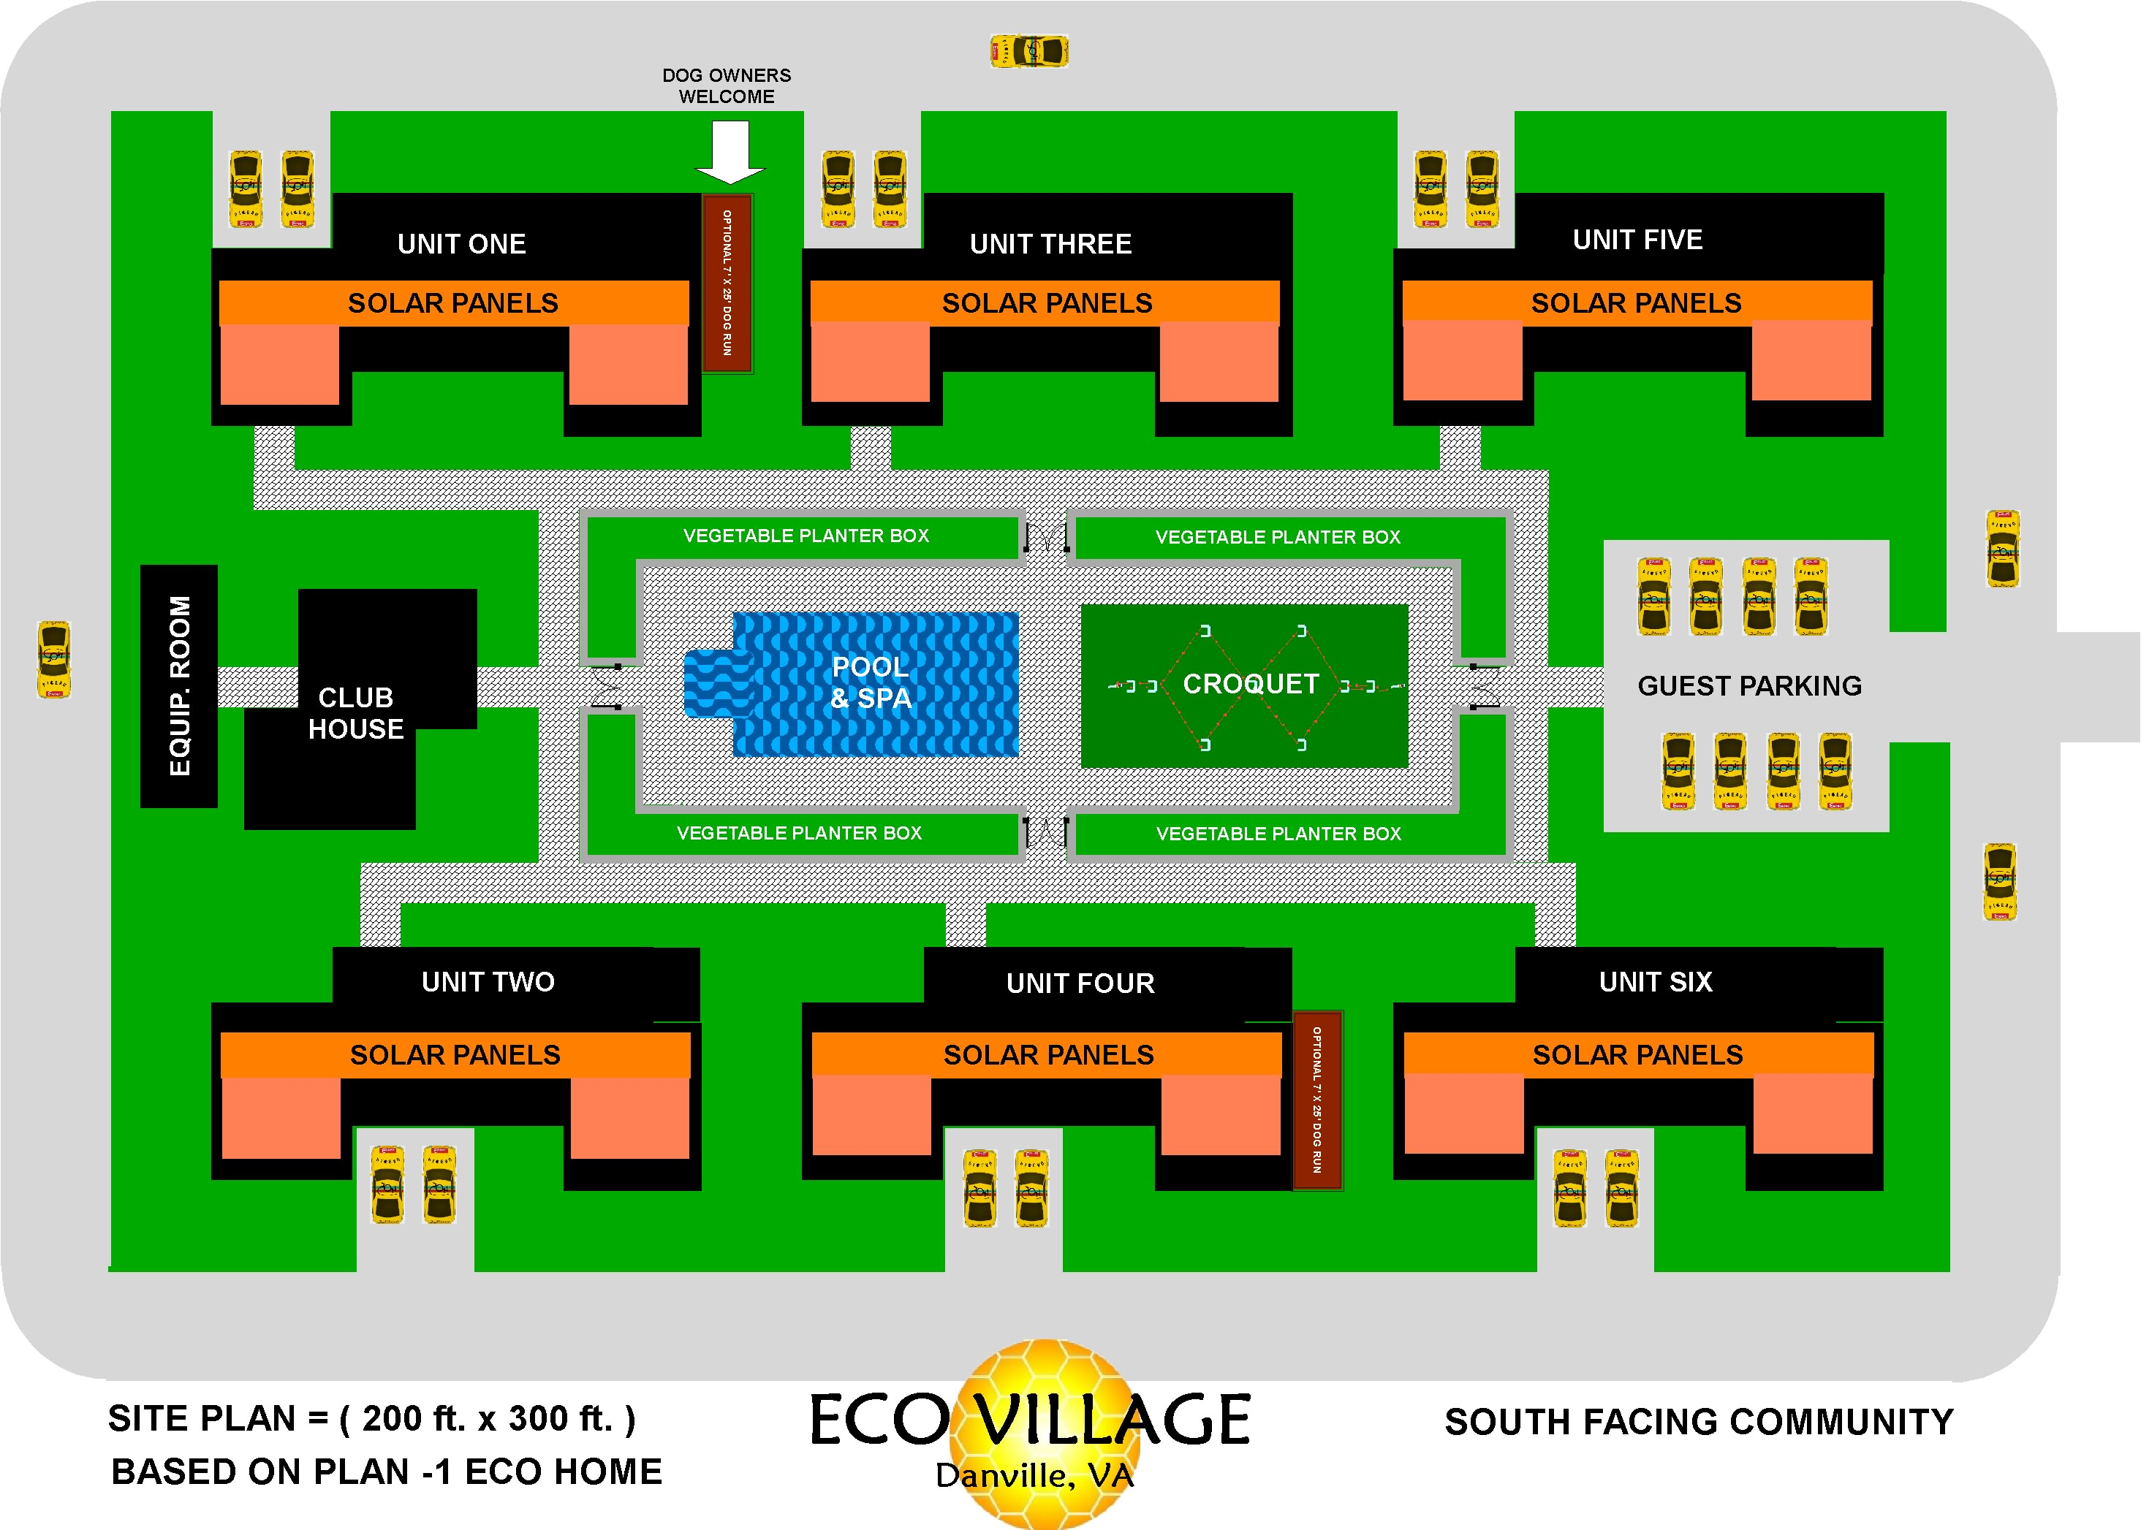

There is a community Pool & Spa, a Club House, Outdoor Barbecue, Tournament Croquet Court, and Community Vegetable Gardens planted at a convenient height of three feet high for us older folks who still like planting a garden but don’t want to bend over backwards to do it. A drip watering system will keep the veggies healthy and happy. Every Home has a Southern face to take full advantage of the Solar Energy design and each has a two car driveway. We plan on using top quality Energy Star appliances, LED lighting systems and induction cook tops. The home will be all electric because the "smart" appliances that can exchange data with "smart" energy meters happen to be electric.
Most conventional homes are built using the old stick frame structure while we plan to use SIPs panels: http://rdcamee.org/ecomod-video The Eco Home can be totally pre-fabricated and shipped to the building site and installed in a day by an experienced crew. The insulation is far superior and is integral with the structural panels themselves eliminating traditional fiberglass insulation and the labor involved installing it.
There is no need for roof shingles, exterior siding or interior dry-wall with our technology!

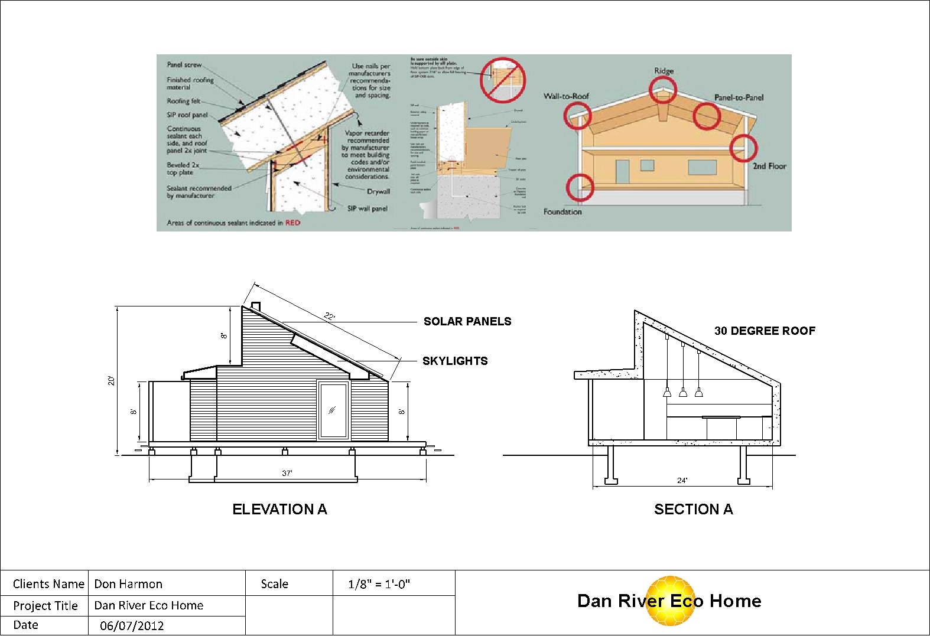

Lithium- ion Battery Storage System:

Our Eco Home features a revolutionary Lithium- ion Battery Storage System made by LiFeBATT. This is a complete Dual Energy System that allows for Grid – Tie or Off Grid (stand alone) functionality. It can be programmed to keep your new home totally sustainable. This is a 12.7 kWh full energy storage system. It is designed to make living Off the Grid entirely possible.

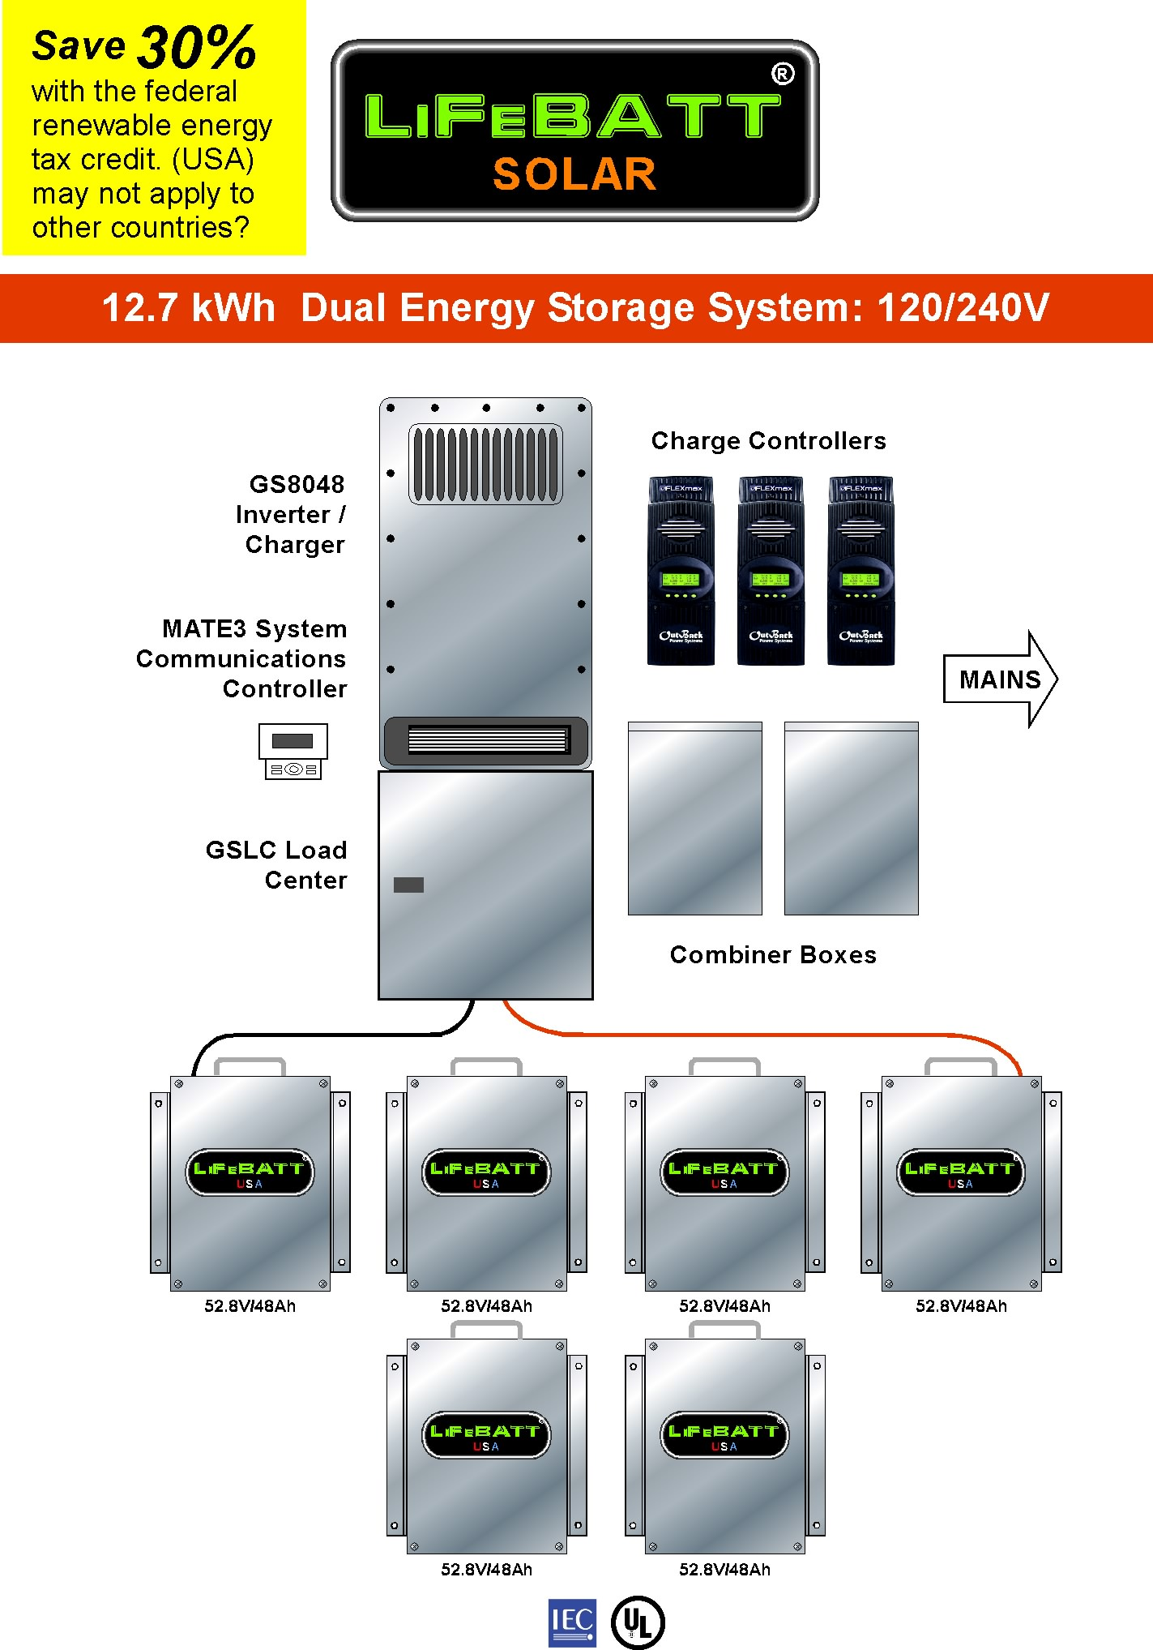
The new LiFeBATT Energy Storage System includes (6) of our nominal 48V/48Ah LiFePO4 battery packs (52.8V/288Ah) and the new OutBack Power Technologies Radian Series GS8048 inverter/charger providing a comprehensive answer for grid interactive and off-grid/stand-alone power systems. Based upon a proven foundation of reliable technology, but engineered from the ground up to simplify the design, distribution, installation and implementation of energy storage, thIs standardized structure and integration with the GS Load Center makes it easy to provide a successful solution to any power requirement, anywhere.

Incorporating a high capacity LiFePO4 battery system, powerful DC to AC true Sine Wave inverter, battery charger and dual AC inputs, its 120/240V split-phase output provides a total power solution which seamlessly integrates with traditional North American wiring practices. Through the use of a single MATE3
multiple inverter / chargers , charge controllers, and DC monitoring devices can be remotely monitored. Unique dual power module design provides high efficiency at both low and full power operation, while providing redundancy for critical applications. The modular design also allows easy field servicing of installed systems.

Prologue:

This is incredible. I had to view it twice. It's another reason why we have to focus on China as a country that is soaring ahead of us in so many areas. This 30-story hotel took 15 days to build!

Notice each of the sections already has electric and water pipes installed and were tested for accuracy all prior to them leaving the factory. It appears like those "sections" formed and pretested at the factory, snug together like Lego building blocks.

I know we are not in Kansas anymore, but I believe we can make Southern Virginia the showcase for affordable sustainable home manufacturing, and produce a lot of jobs in the process. We will be working on locating the money to make some of these projects a reality.

Interested in Investing?

We are in the early start-up phase and are interested in opening a dialogue with potential angel investor(s). We are looking for an initial investment of $350,000US to launch the pilot program which will produce a single Model Home, and in return, we are offering a payout at year three with a residual stake in the enterprise. To learn more, contact Don Harmon, CEO of LiFeBATT, Inc.

Don Harmon

LiFeBATT, Inc.
527 Bridge Street
Danville, Virginia 24541
Tel. 434.489.8509

www.lifebatt.com

